FACILITATOR’S GUIDE

ACTIVITY 3.1 “WHAT IS LOVE?”
Title: Healthy and unhealthy relationships with peers, parents and friends
Activity 3.1: What Is Love? – compare various perceptions of love, and allow comparison to
Materials: Large paper (body size if possible), scissors, marker pens, post-it notes.
Aim: To introduce the concept of healthy relationship and show that love means differently to different people, but no matter what its definitions are, abuse is NOT one of them
Activity:
1. Draw a giant heart on a large piece of paper.
2. Post the heart on the wall and have markers available for activity.
3. Write the words “Love is…” above the heart.
4. Invite each student to provide definitions that answer the phrase “Love is…” by soliciting ideas from the class until the heart appears to be mostly full.

https://image.shutterstock.com/z/stock-vector-red-heart-104762096.jpg

Discussion: Explain that there are many ways to express love between individuals. Taking about healthy relationships often resonates better than addressing dating abuse directly.
1. What types of words are listed in our heart? Are there any that appear a lot or multiple times? What kind of words are these?
2. Is there anything you don’t see in this heart? How do these words make you feel? Not make you feel? Is there anything you were unsure of whether it should be in the heart?
3. Why are there so many different words? Are there words you disagree with?
4. Use the discussion on love to allow students to open up on what are healthy, unhealthy or abusive behaviour. Can there be love in an abusive relationship? Is that a reason to stay in the relationship? Why or why not?
Adapted from https://www.breakthecycle.org Activity Guides

ACTIVITY 3.2 – LET’S SING
Title: Healthy and unhealthy relationships with peers, parents and friends
Activity 3.2: Let’s Sing!
Materials: Radio/tablet/laptop/smartphone and lyrics to the identified song.
Preparation: Find a recent popular songs that students will be familiar with. Have the recordings with you (e.g. through smartphone) and/or print out the lyrics.
Aim: To encourage students to think about what they hear every day on healthy relationships and to appreciate what they hear every day. Think about how negative words impact the way we talk about relationships.
Activity:
1. Play and listen to three or five of these recent popular songs teenagers enjoy.
2. Sing along and write down these lyrics.
3. Go through the lyrics and see what it meant. Ask the students how they feel the about the song and lyrics. How does the lyrics of these songs impact on young people’s relationships? Do these lyrics support healthy relationships?
4. If the group is large, ask students to write down or classify healthy/unhealthy words and behaviours they hear from the song.

https://image.shutterstock.com/z/stock-vector-musician-and-singer-261855038.jpg

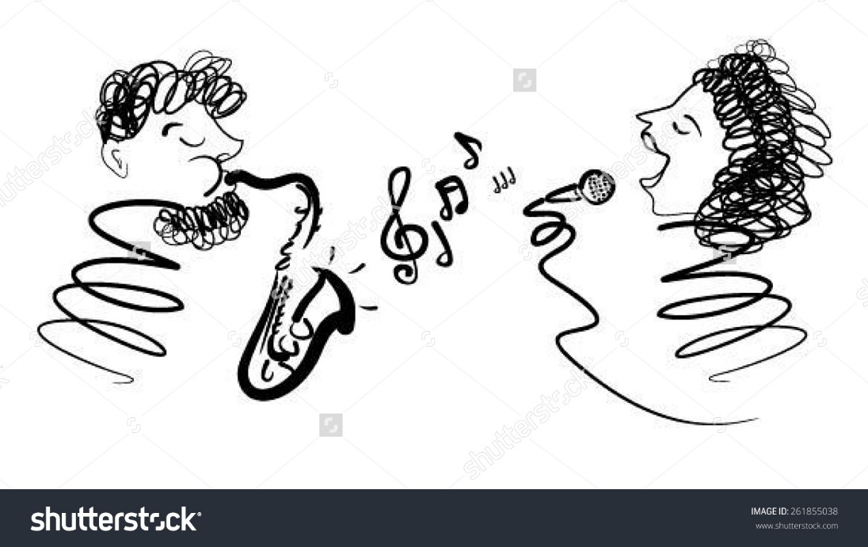

Questions:
1. What songs talks about healthy relationships and why?
2. How does listening to these songs make you feel?
3. What is the impact of these songs on young people’s relationship?
4. Why are these songs popular?

Suggestions of songs:
Malay songs
a) Ketulusan Hati – Anuar Zain
b) Gemuruh – Faizal Tahir
c) Sedalam-dalam rindu – Tajul
d) Pendusta Cinta – Aiman Tino

English songs
a) Hero – Mariah Carey
b) Greatest Love of All – Whitney Houston
c) Shape of You – Ed Sheeran
d) Side to side – Ariana Grande and Nicky Minaj

